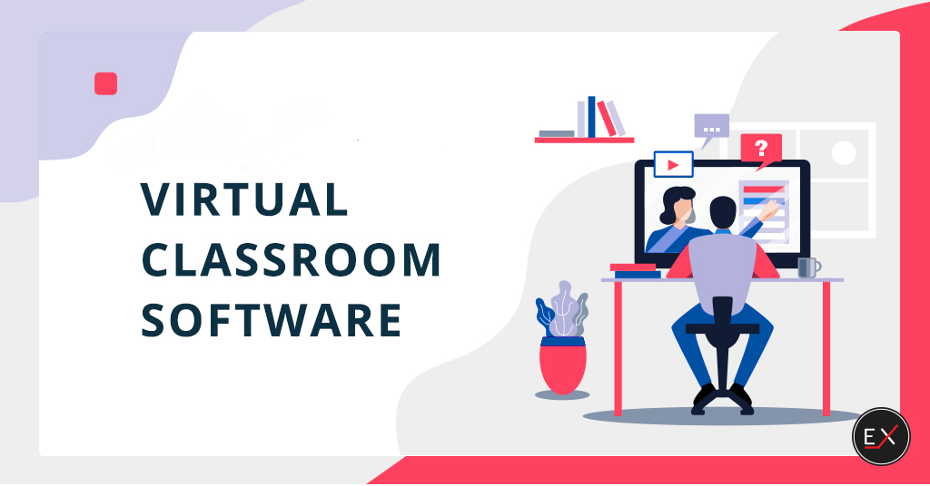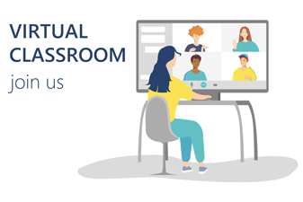

DETAILED SYNOPSIS

## ABOUT PROJECT

Virtual Classroom is a communication platform between student and teacher. In our system there are three users teacher, student and admin. Admin is a owner of a whole system. Teacher and student both are registered user of our site. They have username and password for login in to website.

Registered teachers can upload material for their subject after login to system.  
Online teaching project provide facilities for students to learn online subject and read material and also download material for their subject after becoming a member of this site. And also they can take attendance for their respective courses.

Register student can download and read material online from everywhere using internet.  
Students and teachers can send and receive messages to each other.

## Project modules

1. Admin
2. Staff
3. Students

## FUNCTIONALITIES

### ADMIN

Admin can Login to the site and have the privilege to add branches and add the staff. Manage the staff report, users report and can upload and download the reports of every individual and also provide the feedback.

Admin can also go through the errors in the classroom and can handle them eventually.

### STAFF

Staffs will have the privilege to login into the classroom by their account, upload the documents and pdf related to the assignment or projects.

And with the chat system staffs can chat with the students or can provide the notice regarding any course or class.

They will also have the command over their account, can handle the user name and password according to their preferences.

Staff can even upload download the reports of the progress of the students in class and will also manage the attendance of the students as per their presence in the lectures.

### STUDENTS

Students can login with their account into the classroom and if they are noy registered to the classroom of the particular course, then they can register for it by the link provided in the login page for the students.

Students can download the documents and pdfs provided by the teachers for their assignment purpose or for their project.

Students will also have the privilege to have a professional chat with the teachers regarding any doubts from the lecture.

Students can also manage their account’s password or username by their own, and can even have a look on their progress and attendance in the classes they attend.

